**Brooklyn torah gazette**

**For parshas toldos 5782**

Volume 6, Issue 7 (Whole Number 262) 2 Kilev 5782/ November 1, 2021

**Printed L’illuy nishmas Nechama bas R’ Noach, a”h**

For a free subscription, please forward your request to [***keren18@juno.com***](mailto:keren18@juno.com)

**A Mother’s Promise to G-d**

**To Help Other Mothers of**

**Children with Disabilities**

**By Daniel Keren**

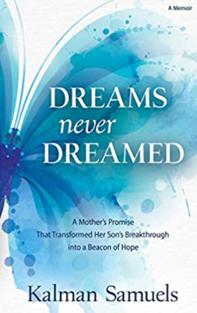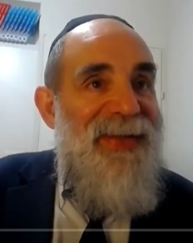

**Rabbi Kalman Samuels, author of “Dreams Never Dreamed”**

I never really know until shortly before the deadline what the topic of my Reviews column in the Jewish Connection will be. I thought I had an idea to write about. However last Wednesday, I was looking to download one of my favorite weekly features titled “Here’s my Story” from the Jewish Educational Medium (JEM), a Lubavitch group dedicated to preserving the historical legacy of the Lubavitcher Rebbe (Rabbi Menachem Mendel Schneerson) of blessed memory.

You never know the individual whose “Here’s my Story” interview about his or her connection to the Lubavitcher Rebbe will be highlighted. Half the time the subjects who were interviewed are not even Chassidim of the late Rebbe.

**A Mighty Mother’s Challenge**

Instead of automatically getting the story for last week’s Parshat Vayeira edition, I somehow “accidentally” came across another fascinating interview from the Parshat Vayishlach 5781 edition of JEM’s “Here’s my Story” titled “A Mighty Mother’s Triumph.”

Rabbi Kalman Samuels along with his wife Malki were given an incredible challenge in 1977. That was when their second child Yossi who had been born a perfectly healthy baby was at the age of 11 months unfortunately given a faulty vaccine that should have protected him from diphtheria, whooping cough and tetanus. Instead, the vaccine which later was found to have come from a faulty batch caused their son to become blind, deaf and very hyperactive.

It just so happened that Kalman’s uncle – Dr. Hershel Samuels on a visit to his nephew in 1981 when the family was staying in Brooklyn “happened to mention one of his patients, [was] a Mrs. Schneerson. He rarely spoke about those whom he treated, but he couldn’t say enough good things about her – how eloquent she was, how cultured, how brilliant.

Kalman asked incredulously if his uncle was talking about the Lubavitcher Rebbe’s wife. Indeed, that was whom he was referring to. Kalman asked if his uncle could get him a blessing from the Rebbe for Yossi, that “it would mean the world to me.” The uncle confidently declared, “No problem, next time that Mrs. Schneerson comes to see me, I will ask her.”

**Uncle Informs Nephew of an Unbelievable Opportunity**

Six weeks later the uncle called him to give over the good news that Rebbetzin Schneerson had arranged it with her husband and that Kalman and his wife and Yossi should the next day at 3 P.M. When Rabbi Samuels called the Chabad shaliach in his hometown of Vancouver, British Columbia to tell him of his special meeting the next day with the Lubavitcher Rebbe, Rabbi Yitzchok Wineberg laughed and warned him – “even my father, a senior Chabad emissary, can’t get to see the Rebbe. Your uncle means well, but I seriously doubt that you will get to see the Rebbe in person.” (Apparently as a result of the Rebbe’s heart attack four years prior, private audiences with the Rebbe were no longer possible.)

But Kalman’s uncle was not wrong and indeed Mrs. Schneerson did indeed persuade her husband to see the Samuels. One of the highlights of that audience was “during the course of the conversation, I mentioned to the Rebbe that Yossi is a direct descendant of King David through his mother. At this point, the Rebbe turned his focus directly to Malki and while addressing both of us, he looked her in the eye with a piercing gaze for several minutes.

**An Astonishing Moment**

“It was an astonishing moment. Later I learned that according to Chasidic teachings, whenever the Rebbe looks at somebody for a long time, it is to transmit spiritual strength to that person. Subsequently, Malki developed extraordinary strength and she ended up founding Shalva, which has developed over the years to be one of the largest and most advanced centers for disability care and inclusion in the world.”

When life became particularly difficult with Yossi, Malki would cry out to G-d, promising that if He would help Yossi, she would dedicate herself to helping others in the same situation.

Rabbi Samuels in the interview relates: “And G-d did help Yossi. After we moved back to Israel, he merited to find the right teacher – Shoshana Weinstock – who was deaf and had an amazing amount of patience.” She was the breakthrough. Shortly thereafter, Malki sat her husband down and declared that now was the time to make good on her promise to G-d and that was how the creation of Shalva was set in motion.

**Dedicated to Providing Transformative**

**Care for Invidiuals with Disabilities**

After reading that interview, I wanted to learn more about the organization that the Samuels founded. If you google Shalva National Center, you will find out that **it is the Israel Association for the Care and Inclusion of Persons with Disabilities and is dedicated to providing transformative care for individuals with disabilities, empowering their families and promoting social inclusion.**

Shalva provides an all-encompassing range of services for thousands of people with disabilities from infancy to adulthood and their families. Shalva’s comprehensive life-cycle programming provide leading-edge therapies, inclusive educational frameworks, social and recreational activities, employment training, and independent living, as well as respite and family support.

Shalva gives equal access and opportunity to all participants regardless of religion, ethnic background, or financial capability.

Among those who have reached out to Shalva National Center to learn more about their breakthrough services are Harvard University, Stanford University and the government of the Kingdom of Saudi Arabia.

You can purchase a copy of Rabbi Kalman Samuel’s inspiring book about his and his wife’s mission to help other parents of children with disabilities by ordering it from the Shalva National Center website.

I also recommend if you have 56 minutes to spare to google a recent 56- minute interview with Rabbi Samuel by the West Orange Modern Orthodox synagogue Ahawas Achim B’nai Jacob & David - “youtube – Dreams Never Dreamed – Kalman Samuels”

*Reprinted from last week’s edition of The Jewish Connection.*

**Thoughts that Count**

**For this Week’s Parsha #1**

*Yaakov gave Esav bread and lentil soup (Gen. 25:34)*

Esav only asked for lentil soup, but when he came in hungry from the field, Yaakov first gave him bread. Yaakov would not take advantage of Esav's hunger to receive the birthright, and Esav wouldn't be able to claim that he had sold it under duress, making the sale null and void. Yaakov gave Esav bread, and when Esav was no longer hungry, Yaakov asked him if he still wanted lentil soup in exchange for his birthright. *(Y'dei Moshe Al Midrash Raba)*

*Reprinted from Reprinted from the 5757/1996 Toldos edition of L’Chaim Weekly*

**Parshas Toldos:**

**The Age of Disrespect**

**By Rabbi Bentzion Shafier**

**Founder of TheSmuz.com**

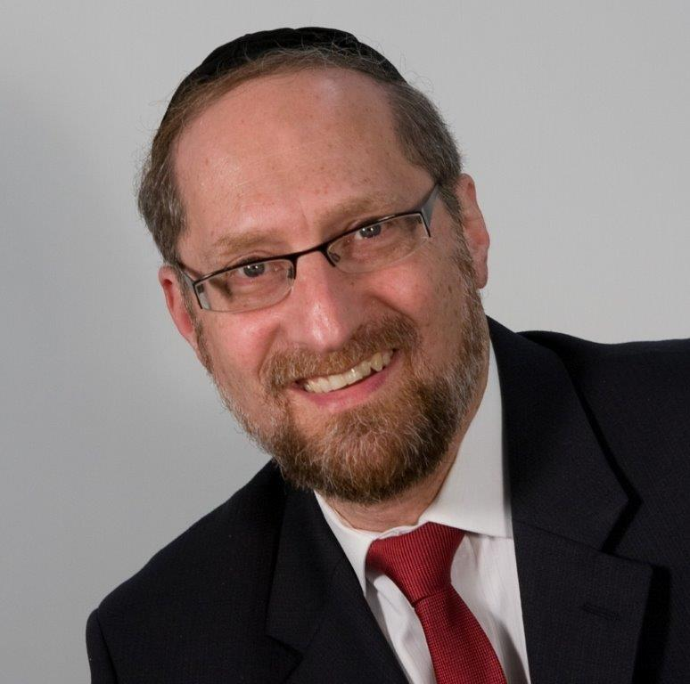

*And Lavan and Besuel answered and said, “The matter stemmed from HASHEM. We are unable to speak to you either good or bad.”* — Bereishis 24:50

Eliezer, the servant of Avraham, went to find a wife for Yitzchak. He approached the city of Charan, waited at the well, and asked HASHEM for a sign. “Let it be that the girl who not only gives me water when I ask for it, but says, ‘Not only will I give you to drink, but I will give your camels as well.’ She should be the one that is right for Yitzchak.”

No sooner did he finish speaking than Rivka, the daughter of Besuel, came upon the scene and fulfilled his request exactly as he specified. Eliezer knew that he had found the right one.

He then asked Rivka to take him to her father. As they neared the house, Rivka’s brother Lavan saw the camels laden with treasures, ran out to greet the new guest and usher him in. Eliezer described the miracles that happened and then asked for approval of the marriage. Lavan and Besuel exclaimed, “It is from HASHEM! How can we stop it?”

Rashi comments that from here we see Lavan’s wickedness. Why did the Torah mention his name first? To teach us that he spoke before his father. This shows us that he was a rasha.

**The Disrespect of Lavan**

This Rashi is difficult to understand. Why does Lavan’s speaking before his father show that he was wicked? Disrespectful — yes. Rude — certainly. But a rasha?

The answer to this can best be understood from a historical vantage point.

In the 1980’s, a yeshivah student learning in Israel found himself on a bus, sitting near two secular American Jews. Noticing that one was a bit older than the other, he was surprised to hear them calling each other by their first names. “Bob, did you notice that?” said one. “Hey, Joe, what do you think?” said the other. His surprise deepened when in the course of conversation it became clear that the two were father and son. Dad explained, “I don’t want barriers between us, so we call each other by our first names.”

That wasn’t the way that it used to be. In the 1930’s in America, a teenager wouldn’t dream of calling an adult by his first name, let alone his father. And certainly, a child wouldn’t dare open his mouth when his father spoke. It didn’t matter how foul-mouthed the child was, and it didn’t matter how unpolished the father was. Children knew their place, and the idea of a child speaking back to an adult was unheard of.

**The Counter-Cultural Revolution**

Things have changed a bit since then. The counter-cultural revolution of the 1960’s brought new attitudes and ideas. Police became “pigs.” Government came to be mistrusted. And anyone over the age of thirty was part of the problem. While much of the hysteria of those times has passed, one of the relics is that respect is no longer part of the culture. Gone is respect for leaders. Gone is respect for the clergy. Gone is respect for elders. In its place is the cynicism of a new age — an egalitarian age — where we are all equals.

We no longer need to treat institutions with reverence, and we no longer need to treat authority with deference. And so, we argue with our doctors. We argue with our lawyers. And we argue with our parents — who don’t really know that much anyway. Welcome to the Age of Disrespect.

This seems to be the answer to this Rashi. In the times of Lavan, society was still normal. Workers respected bosses. Students respected teachers. Younger people respected older people. As such, there were things that were done and things that were not done. In that world, for a child to answer in his father’s presence was outrageous. It simply didn’t happen. The only time such a thing could occur was when the child had veered way off course — he had become deviant. And so, Rashi tells us that Lavan’s response shows just how wicked he was.

This is especially illustrative because Besuel wasn’t known as a paradigm of virtue. He died trying to poison Eliezer in order to steal his money. Yet, even in his home, for a child to answer before his father did was so out of the norm that it could only happen if that child was wicked.

This concept is relevant to us because while we are a nation, separate and distinct, the reality is that we learn from those around us. And so we need to be mindful of what we consider normal and acceptable behavior. What we see in the world at large isn’t normal — and it certainly isn’t acceptable. We need to teach our children that this isn’t the way. Just because it’s done doesn’t make it tolerable. There will again come a time when people will look back at such behavior with the appropriate sense of horror, shock, and disbelief.

*Reprinted from the current website of TheShmuz.com*

**Thoughts that Count**

**For this Week’s Parsha #2**

*Esav said in his heart,"May the days of mourning for my father arrive, then I will kill my brother Yaakov. (Gen.27:31)*

Esav waited until his Yitzchak passed away because he knew that Yaakov learned Torah - day and night. He knew that the merit of learning Torah would prevent him from being able to harm Yaakov. It is forbidden to study Torah during the time of mourning, and therefore Yaakov would lack protection. *(Shaar Bat Rabim)*

*Reprinted from Reprinted from the 5757/1996 Toldos edition of L’Chaim Weekly*

# Rav Avigdor Miller

# On Pleasure of the

# World to Come



**QUESTION: If every hour in the World To Come becomes more and more enjoyable like you said before, are we expected to desire to get there sooner so that we can start increasing our enjoyment already?**

ANSWER: And the answer is, Moshe Rabbeinu knew more about the World yo Come than we do.  And so, when Hakodosh Boruch Hu told him, ויאמר ה’ אל משה הן קרבו ימיך למות – your days are close to die, Moshe Rabbeinu should have made a kiddush.  Instead, he put out the biggest protest that anybody ever did against dying.  ואתחנן אל השם בעת ההיא – I entreated Hashem.

And the medrash explains that Moshe Rabbeinu went around praying and crying and protesting; he didn’t want to die.

The answer is, the longer you’re here, the more opportunity you have to enter the next world with a greater capital. And if you come with a bigger capital, then you’re going to have a much greater eternity of happiness.

And therefore, יפה שעה אחת של תשובה ומעשים טובים בעולם הזה מכל חיי עולם הבא – It’s better to remain one more minute in this world with repentance and good deeds more than the entire life of the World to Come.  Because this opportunity that you can get here, you’ll never find available in the World To Come.

*Reprinted from the October 28, 2021 email of Toras Avigdor (Tape 447)*

**Thoughts that Count**

**For this Week’s Parsha #3**

*He summoned his older son Esav -.(Gen. 27:1)*

When Yitzchak called Esav to give him his blessing, the Torah refers to Esav as the "older" or "greater" son. Why is the wicked Esav referred to as greater? G-d told the Jewish people that before the Redemption, Esav and his children will have control over the world. When the Redemption comes, Esav will pay for his wickedness. *(Tanchuma)*

*He will give me bread to eat and garments to put on. (Gen.28:20)*

It seems unneccessary for Yaakov to add the words "to eat" and "to put on," because that's obviously what food and clothes are for. Yaakov isn't only asking G-d to bless him with food and clothing, but also to bless him with the good health to enjoy them. Unfortunately, there are people with an abundance of food and clothing who are unable to enjoy either. *(Siftei Cohain)* *From Vidibarta Bam, compiled by Rabbi Moshe Bogomilsky*

*Reprinted from Reprinted from the 5757/1996 Toldos edition of L’Chaim Weekly*

**Rabbi Berel Wein on**

**Parshat Toldot 5782**

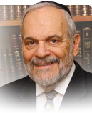

This week's Torah reading begins with the recounting of the generations of Abraham and Isaac. It is titled “Toldot,” which literally means the children, as it relates to genealogy, and generations. The Torah reading of a few weeks ago also recounted for us the genealogy and generations of Noah and his sons. But that portion of the Torah was titled “Noach” and not “Toldot.”

The opening verse in both instances is practically identical, but the names of the Parshiyot are different. Is there any reason why the previous Torah reading should be called based on the name of person involved, and our Torah reading this week should be called based on the generations and genealogy being described? The Torah reading of this week should have been titled Yitzchak, like the Torah reading of Noach.

Although this is hardly the most pertinent observation regarding this week's Torah reading, it has bothered me for several years, and I have found relatively few explanations from the great commentators, who usually have many observations in answer to obvious questions such as this in our eternal Torah. I gave the matter some concentrated thought this past week, and as is usual when one concentrates upon a Torah subject, a glimmer of understanding concerning this matter came to me. It is this idea that I wish to share with you in this week's article regarding the weekly Torah reading.

There is an inherent difference between the generations and genealogy of Noach and that of Yitzchak. Both are survivors of great events of danger and trauma. It would be impossible to survive seeing the entire world destroyed, as in the case of Noach, or being sacrificed willingly by one's own father, as was the case with Yitzchak, without these events having a lasting impact upon the survivors who witnessed and experienced them. But it is the reaction itself that differentiates between these two righteous people.

Noach, as a survivor, attempts to wipe out the memory of what happened from his conscious mind and behavior. That is why he plants a vineyard, produces wine (to possibly,) becomes drunk, and is shamed and violated by his own progeny. It is understandable that he would want to forget what happened and what he witnessed, and not burden future generations with the memories of the trauma that remains buried within his subconscious. The key to further survival is to forget the past and not transmit it to the later generation.

Therefore, the Torah reading involving his life is called only by his name, since there is no intention to transmit to future generations what transpired and why it occurred. In addition, since Noah's shame came specifically through his children and grandchildren, his “toldot,” it would have been improper to call the Parsha by their name, calling attention to Noah's trauma.

However, in the case of Yitzchak, far from attempting to forget his being bound on the altar by his father, he desires to transmits that memory and trauma to his descendants, the Jewish people, until this very day. We revere the experience of our father Yitzchak, and his willingness to sacrifice himself for the sake of the G-d of Israel. This experience has become a hereditary hallmark of Jewish life, and we remember it as a symbol of continuity of generations, and not just as the experience of one individual, no matter how great that individual may have been.

*Reprinted from the current website of rabbiwein.com*

**The Secret for the Success of the “Generations of Isaac”**

**From the Talks of the Lubavitcher Rebbe**

**Rabbi Menachem Mendel Schneerson, Zt”l**

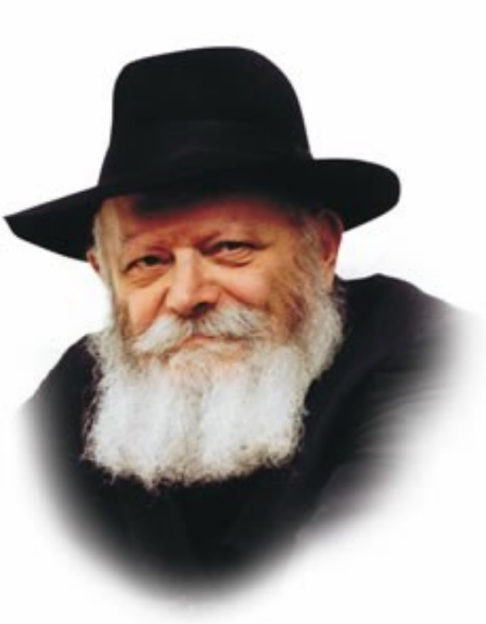

This week's Torah portion, Toldot, begins with the words, "These are the generations of Isaac, the son of Abraham: Abraham begot Isaac." What is the meaning of the repetition in this verse? By stating "the son of Abraham" and "Abraham begot Isaac" -- two ways of expressing the same idea--the Torah offers us the reason for "the generations of Isaac":

The generations of Isaac are the consequence of Abraham having begotten Isaac.

Abraham, as the Torah relates, was "one" -- the only Jew in the entire world. The whole world stood in opposition to Abraham, as the name "Ivri--Hebrew" (from the word "eiver--side") -- implies. The entire world was on one side and Abraham on the other. Nonetheless, Abraham persisted in his mission to make G-d's Name known, as it states, "And he called there in the name of the L-rd, G-d of the world."

This approach was passed on to Abraham's son Isaac as an inheritance, thereby paving the way for the possibility of future "generations of Isaac" --- both in the spiritual sense (according to the explanation of our Sages that the primary "descendants" of the righteous are their Torah, mitzvot and good deeds) and the physical sense, actual offspring.

**A Lesson for Every Jew**

This contains a lesson for every Jew in his daily life. When a Jew takes a look at the world, he is apt to become discouraged. Evil people seem to prosper and flourish, and countless obstacles stand in the way of his service of G-d. For most of the day he must involve himself in mundane affairs; it is an ongoing struggle to bring holiness into his life. The Jew is liable to wonder where he will get the strength to observe the commandments and perform good deeds. How can he withstand the many trials that he must endure?

The answer is contained in this week's Torah portion.

"The deeds of the forefathers are a sign for their children" -- and not only a sign or indication of how they should conduct themselves, but an infusion of strength. "Abraham begot Isaac" --Abraham was the rock from which Isaac was hewn, and the source of strength for all Jews.

**The Courage to Know One Can**

**Overcome all Hindrance and Impediments**

Just as Abraham did not flinch at taking on the entire world, spreading the belief in one G-d and the knowledge that "there is none but Him," so too must every single one of Abraham's descendants take courage in his ability to overcome all hindrances and impediments that come his way.

By striving to fulfill "the generations of Isaac" in the spiritual sense, i.e., Torah, mitzvot and good deeds, we thereby merit to become "the generations of Isaac" in the literal sense as well, vanquishing the enemies of G-d and His Torah in preparation for the conquest of the holy land, at the hands of Moshiach.

*Reprinted from Reprinted from the 5757/1996 Toldos edition of L’Chaim Weekly, adapted from Likutei Sichot, volume 1.*

**Lacing a Shoe**

**By Rabbi Chaim Hillel Raskin**

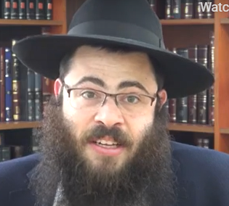

My shoelaces ripped on Shabbos. Can I replace them? Shulchan Aruch rules that one may not insert a lace into the eyes of a new shoe on Shabbos, as the lace completes the shoe’s form, and it is thus a melacha of makeh bepatish, “delivering the final blow.”1

Even an “old” lace that was used already in a different shoe may not be inserted into a new shoe, since it still completes the shoe.2

If one started to insert the lace before Shabbos but didn’t manage to finish, he may finish on Shabbos.3 If the lace fell out of the shoe, one may put it back in, on condition that the holes are sufficiently wide and it is easy to lace without undue effort; but if the holes are narrow it is forbidden.

**The Problem is Tircha, Working Hard on Shabbos**

Some poskim explain that the problem is the tircha, working hard on Shabbos, but the Alter Rebbe writes that inserting it with effort is like putting it in for the first time, which would be makeh bepatish. 4 (A nafka mina: you may ask a non-Jew to do tircha for you, but not makeh bepatish. 5 )

The prohibition of lacing a shoe applies to any inserting of a string, strap or elastic into clothing that is meant to remain indefinitely (e.g. a lace in a hood). A belt, however, isn’t a problem since it isn’t left indefinitely, rather is inserted and removed regularly.6

What if the shoe or garment previously had a lace, but now one is inserting a new one? Is this still considered completing the shoe or clothing? The Elya Raba holds that this is prohibited, since it is considered “fixing” it and so rule many contemporary poskim. 7 However, the Ketzos Hashulchan points out that the Alter Rebbe only speaks of a new shoe—in which case one “completes” it with the laces—and not of laces that are “new” to the shoe.

Additionally, our shoes are somewhat wearable, and “complete” even without laces. Therefore, in practice, one may replace new laces into a shoe that was previously laced.8 Even if the shoes are new and never had laces, if one inserts the laces in a manner that they definitely won’t remain for long in the shoe, it is permissible and not considered makeh bepatish. This can be accomplished by skipping some of the holes or using a different color lace, in which case he will certainly redo it after Shabbos

1 .ראה שוע"ר או"ח סי' שי"ז ס"ה. 2 .ראה שש"כ פט"ו סנ"ט הע' קצ"ט. 3 .שש"כ שם הע' ר"ב. 4 .ראה רמ"א סי' שי"ז ס"ב. 5 .פסק"ת סי' שי"ז הע' 55. 6 .שוע"ר סי' שי"ז ס"ה. 7 .א"ר סק"ז הובא במשנ"ב סקי"ח. וראה שש"כ פט"ו סס"ד והע' רט"ו. 8 .ראה קצוה"ש סי' קמ"ו בדה"ש סק"ג. 9 .קצוה"ש שם

*Reprinted from the Parshat Toldos 5782 of the Merkaz Anash’s The Weekly Farbrengen edited by Rabbi Shimon Hellinger.*

**The Dancing and Singing**

**Of Dovid Hamelelch**

When it was time for the Aron to be brought up to Yerushalayim, Dovid HaMelech gathered with a large multitude to celebrate the occasion. He danced with all his might and sang praises in a manner generally unbefitting for a king.

His wife, Michal, watched from the window and disapproved of his conduct. When he finally returned home, Michal greeted him scornfully, “How honored was the king today as he exposed himself in front of the people like one of the boors!” Dovid replied, “In the presence of HaShem I will rejoice, and I will act even more humbly and be lowly in my eyes.” ) (Shmuel Beis – Chapter 6)

*Reprinted from the Parshat Toldos 5782 of the Merkaz Anash’s The Weekly Farbrengen edited by Rabbi Shimon Hellinger.*

**The Last Struggle**

**Of the Yetzer Ha’ra**

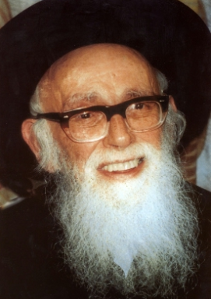

**Rabbi Shlomo Zalman Auerbach**

The lads grew up and Esav became one who knows hunting, a man of the field; but Yaakov was a wholesome man, abiding in tents.” (25:27) Rashi z”l explains: As long as they were young, they could not be distinguished by what they did, and no one paid much attention to their characters.

But, when they turned thirteen, one [Yaakov] went to the house of learning and the other [Esav] went to temples of idolatry. [Until here from Rashi]

R’ Shlomo Zalman Auerbach z”l (1910-1995; one of the leading halachic authorities of the 20th century) said at a Bar Mitzvah celebration: We understand why, immediately upon becoming a Bar Mitzvah, Yaakov dedicated himself to Torah study.

**The Appearance of the Yetzer Ha’tov**

After all, our Sages say the Bar Mitzvah day is when the Yetzer Ha’tov/ good inclination enters a person. But, it seems from Rashi’s words that immediately, on that same day, Esav turned into an idolator. How did this happen on the very day when Esav received the Yetzer Ha’tov?

R’ Auerbach answered: The Gemara (Sanhedrin 91b) teaches that the Yetzer Ha’ra enters a person when he is born.

But, being alone in the child–as the Yetzer Ha’tov will not arrive until 13 years later–the Yetzer Ha’ra does not exert itself too much, R’ Auerbach said.

Only when Esav became a Bar Mitzvah and received his Yetzer Ha’tov did his Yetzer Ha’ra begin to “fight for its life” by asserting itself. Thus, on that very day, Esav succumbed to the Yetzer Ha’ra and became an idolator. (Quoted in Tiv Ha’bacharut p.27) R’ Yitzchak Traube (Kiryat Belz, Yerushalayim) writes, citing many Chassidic works and earlier sources, that the Yetzer Ha’tov actually is present in a person before he

is born. After all, the well-known Gemara teaches that babies study Torah in the womb. However, when a child is born, the Yetzer Ha’tov departs, and the Yetzer Ha’ra enters. Why? Because the very purpose of our existence is to bring “light” into a “dark” world. And, the greater the “darkness,” the more stark is the “light” that follows. Therefore, of necessity, the “darkness” must precede the “light.” (Mesilot B’ohr Ha’chassidut: Bar Mitzvah- Hamaayan)

*Reprinted from the Parshat Toldot 5782 of Reb Yedidye Hirtenfeld whY I Matter, the parsha sheet of the Young Israel of Midwood (Brooklyn).*